Design, Development & Governance — Milestone 2

A. Design Problems and Pattern Decisions
The problems discussed come from M1 baseline requirements for CivicConnect. The record format follows Nygard (2011). The problem is stated before pattern is named as well as project specific decision is record with is benefit and cost. The previous ADR is used as evidence

A.1 Design Problem 1 — Controlled request status lifecycle (DP-1)
Context: M1 2.1 defines a transition, for giving requesters honest visibility. FR-011 requires only verified transitions to be recorded while FR-013 lets authorised staff resolve or close. NFR-018 restricts actions by role.
Problem: These rules that determine legal or permissible transitions are used in multiple places, example: staff updates, resolve/close., if they are written as scattered conditions, one code path will eventually allow an illegal move. This could cause a corruption in the history that FR-014, FR-015 and NFR-020 depend on. Thus, we need to design the system to keep the rules in one place, which can be tested thoroughly
Lifecycle rules: Only 7 of the 36 transitions are legal in this case. Closed or rejected are terminal. The right-hand column records the policy that the rule must implement. While the authorisation, is decided outside of the lifecycle
From | To | Required input | Authorisation policy (Identity & Access) | Reqs
Submitted | Acknowledged | — | Authorised staff | FR-011, FR-006
Submitted | Rejected | Reason | Authorised staff | FR-011, FR-006
Acknowledged | In Progress | Assignee set | Assigned staff member | FR-010, FR-011
Acknowledged | Rejected | Reason | Authorised staff | FR-011, FR-006
In Progress | Resolved | Resolution note | Assigned staff member | FR-012, FR-013
Resolved | Closed | — | Authorised staff | FR-013
Resolved | In Progress (reopen) | Reason | Authorised staff | FR-011

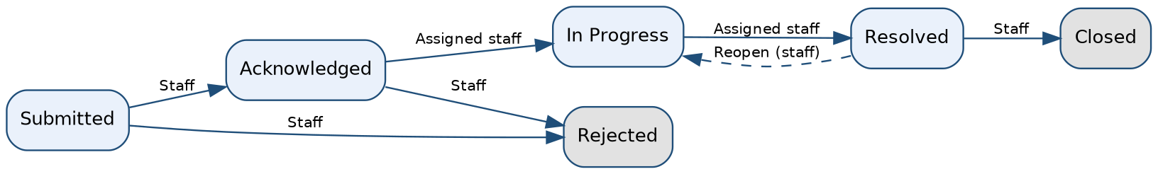
Figure A1 — Legal status transitions (solid = forward path, dashed = reopen). Matches PED §4.3.

ADR-006 — Use the State pattern for the request lifecycle
Field | Record
Status / date / owner | Proposed | 30/9/2026 | Person 3 (Accepted when the M2 baseline is signed)
Decision | Model each status as a state object behind a RequestState interface. ServiceRequest.transitionTo(target, actor, note) first asks Identity & Access whether the actor may act (ADR-003), then delegates to its current state, which either accepts the target and supplies the new state or rejects it with a reason. The change and its audit record are then committed together (ADR-004, ADR-005). States decide legality and required inputs; they never inspect roles.
Alternatives considered | (a) Conditional logic (if/else or switch) in the request service: simplest to write, but this is the form of code the State pattern is designed to replace when behaviour depends on state (Gamma et al., 1994, pp. 305–313; Freeman and Robson, 2020).  (b) Data-driven transition table (map of from/to/required input): also centralised and lighter than State, and the closest alternative.  (c) State pattern (chosen).
Why (c) over (b) | Transitions carry behaviour as well as permission: terminal states reject everything, In Progress requires an assignee, and Rejected/Resolved/Reopen require a note. Per-state classes keep that behaviour cohesive and testable one state at a time. Team judgement, to be defended at the presentation: a table would need extra condition code for the same cases.
A2 evidence | The pattern is documented by PED/ADR observer-based reactions are displayed in application code. Separate validation procedures are displayed by PED/ADR and application code. PED/ADR, data model and application transaction/validation logic. PED/ADR, architecture diagram and application interface implementation. Repository settings, PR history, CI workflow/results and project documentation.
Benefit | One owner for lifecycle rules (NFR-023, ASR-4); adding a status touches one class; each rule is unit-testable without a database (ASR-2 requires invalid transitions to be rejected 100% of the time in tests).
Complexity / trade-off | Gamma et al. (1994, pp. 305–313) note that State spreads behaviour over more classes than one conditional would and is worthwhile mainly when there are many states. Six states is near the lower limit, so this cost is real. Mitigation: states are stateless and shared, no framework is added, and ServiceRequest depends only on the interface, so falling back to option (b) is a contained change.
Affected components | Request Management: ServiceRequest, RequestState and concrete states, RequestService; the transitions endpoint (B.2); StatusHistory persistence; reporting queries for open/overdue.
If reversed | RTM rows FR-010, FR-011, FR-013 (design, implementation, verification), the transition test suite, Figures A1/A2, R10 and README module notes would change. The API contract in B.2 would not.
Traceability | FR-010, FR-011, FR-013, NFR-018, NFR-020, NFR-023; ASR-2, ASR-4; ADR-003, ADR-004; risks R6, R10.

A.2 Design Problem 2 — Audit trail and requester feedback on every status change (DP-2)

Context: NFR-020 require major changes to be tracked. It requires a status, and responsible staff member to be added. FR-006 only needs feedback from the request when the status get changed. M1 3.3 we decided to defer SMS/emails, so in-app pop ups and notifications are within scope but other channels are expected later on for ASR-4. ADR-004 is a fix for the rule that allows audit record to be written with the same transaction as the change. It prevents the end user to be connected to each part of every lifecycle.

Problem: When successful change is completed a audit record and requester-visible update must be produced. This applies to every code path that changes a request. This is to provide a robust change log and support debugging. But if a Request Management calls audit and notification code directly, the core lifecycle is coupled to both processes. A new change means editing core present/future code will forget a call silently and breaks auditability. The audit record must never be missing when a change is committed.

ADR-005 — Use the Observer pattern (synchronous, in-process) for status-change side effects
Field | Record
Status / date / owner | Proposed | 30/9/2026 | Person 3 (this is the ADR-005 candidate Person 1 asked the team to assign)
Decision | On a successful change, Request Management publishes a StatusChanged (or AssignmentChanged) event through RequestEventPublisher, which notifies subscribed RequestEventListeners (Gamma et al., 1994, pp. 293–303). Two listeners are registered in one composition point: AuditTrailListener (Audit module; appends a StatusHistory row) and NotificationListener (Notification module; records an in-app update through a NotificationChannel). Both run synchronously inside the same unit of work as the change (Fowler, 2002), so the transaction either commits all of it or none (Kleppmann, 2017, ch. 7). This is the mechanism that realises ADR-004; it is not the asynchronous “separate process or event” that ADR-004 rejected.
Dependency direction | The event types and RequestEventListener interface are part of Request Management’s published interface. Audit and Notification implement that interface and never call Request Management back, in line with Person 1’s rule that dependencies point inward (Martin, 2017) and rule 3 in PED §4.1. Confirm rule 3 is intended to permit implementing a published listener interface; if not, move the event contract into a small shared kernel and update ADR-002.
Extension point (ASR-4) | The Notification module exposes a NotificationChannel interface. An in-app channel is implemented now; email/SMS (M1 §3.3, deferred) become new channel classes attached after commit, so an external outage cannot block staff work.
Alternatives considered | (a) Direct calls from Request Management to audit and notification code: least indirection, but coupling and the forgotten-call risk above.  (b) Asynchronous queue or message broker (Hohpe and Woolf, 2003): decouples fully, but adds infrastructure and eventual consistency, which works against “exactly one audit record per change” (Newman, 2021) and is disproportionate for a three-person team on a free-tier assumption (M1 §4).  (c) Database triggers for audit: rejected in ADR-004 (logic hidden from code review, harder to test); also cannot produce requester updates.  (d) Observer, in-process and synchronous (chosen).
A2 evidence | The pattern is documented by PED/ADR observer-based reactions are displayed in application code. Separate validation procedures are displayed by PED/ADR and application code. PED/ADR, data model and application transaction/validation logic. PED/ADR, architecture diagram and application interface implementation. Repository settings, PR history, CI workflow/results and project documentation.
Audit content | Each history row records who, what and when: actor, request, from-status, to-status, timestamp and note, following the event attributes recommended for security logging (OWASP Foundation, n.d.a). Rows are append-only (ADR-004).
Benefit | Lifecycle code no longer knows about auditing or notification (ASR-4, NFR-023); a new channel is a new class; the audit guarantee is enforced in one place; listeners are testable in isolation.
Complexity / trade-off | Gamma et al. (1994, pp. 293–303) note that observers add indirection and can produce unexpected cascading updates, so control flow is harder to follow. Listener order and failure behaviour must be documented. Synchronous listeners add latency to each change; the NFR-024 target (95% of regular operations within 3 seconds, as clarified by CR-001) is expected to hold at this scale and will be measured in M3. Failure rule: if the audit write fails, the change is rolled back, deliberately favouring accountability (M1 §1.1). Mitigation: only two listeners and a test that fails if the audit listener is not registered.
Affected components | Request Management (RequestService, publisher, listener interface), Audit (AuditTrailListener, StatusHistory), Notification (NotificationListener, NotificationChannel), history and notifications endpoints (B.2).
If reversed (e.g. to a queue) | The transaction rule, the deployment footprint (extra service), R11, README run instructions, Person 2’s persistence ADR and NFR-022/NFR-024 verification would change; so would ADR-004 and RTM rows FR-006, FR-014, NFR-020.
Traceability | FR-006, FR-012, FR-014, NFR-020, NFR-022, NFR-023; ASR-2, ASR-4; ADR-002, ADR-004; risk R11.

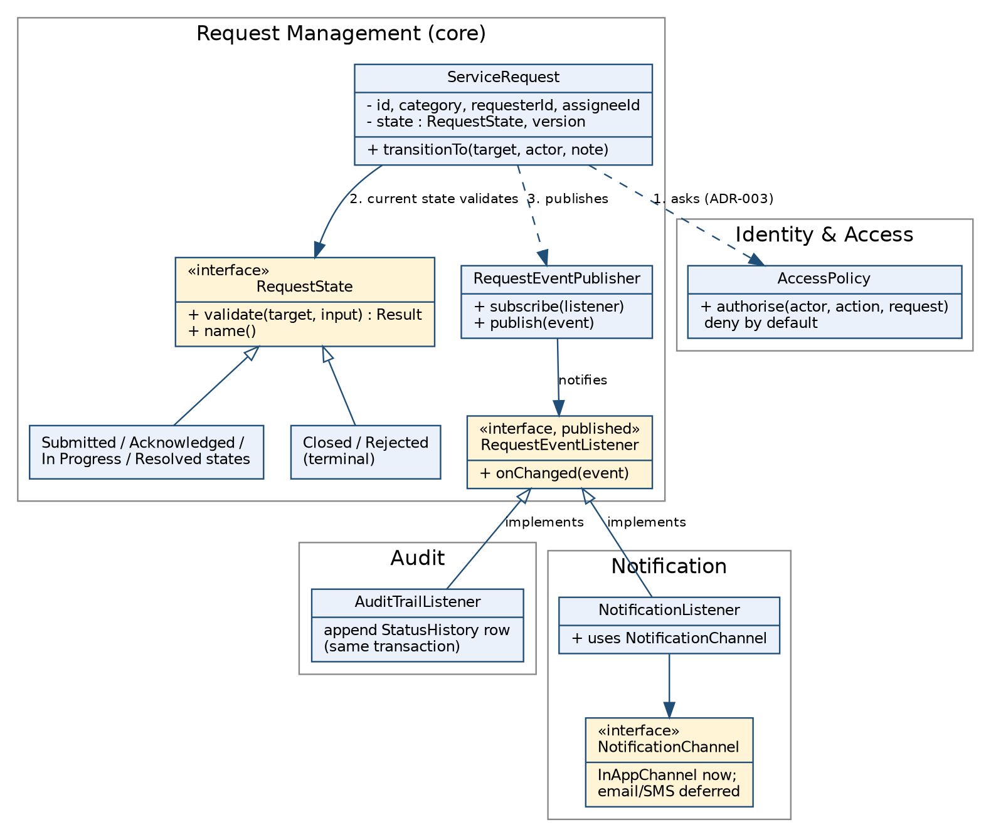
Figure A2 — Design diagram: State (DP-1) and Observer (DP-2) across the Request Management, Identity & Access, Audit and Notification modules.

A.3 How the two decisions work together
A transition request runs in this order: authenticate, authorise through Identity & Access (ADR-003), validate through the current state (ADR-006), apply the change and publish the event inside one transaction (ADR-004, ADR-005). If authorisation or the state rejects the request, nothing is published, so the history contains only verified transitions, which is the acceptance criterion of FR-011 and the ASR-2 target.
Initial application evidence: Lifecycle evidence lives under the “feature/status-lifecycle” branch on the repo.

B. Interface / API Decisions

B.1 Boundaries and mechanism
CivicConnect has one genuine network boundary: the browser client talking to the application server (PED §4.4). The six modules are logical units inside one deployable, so calls between them are ordinary in-process calls through published interfaces (ADR-002). No microservice or external integration is created, consistent with the M1 exclusion of third-party/municipal integrations and the brief’s proportionality rule.
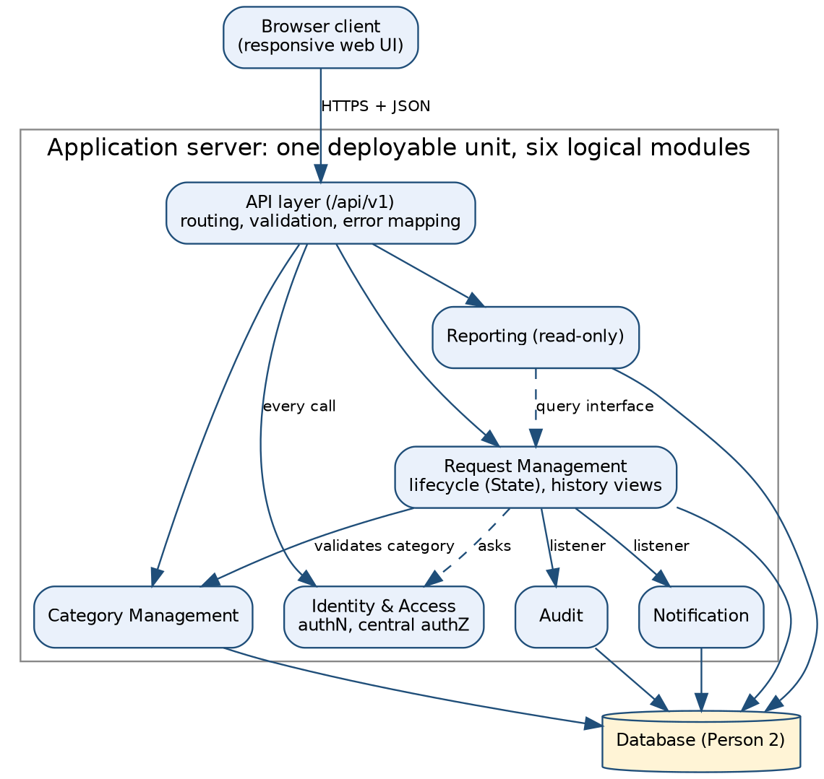
Figure B1 — Modules and the single network boundary (browser ↔ API layer).

ADR-007 — Resource-oriented JSON API over HTTPS, versioned under /api/v1
Field | Record
Status / date / owner | Proposed | 30/9/2026 | Person 3
Decision | A resource-oriented API in the REST style (Fielding, 2000, ch. 5) using standard HTTP methods and status codes (Fielding, Nottingham and Reschke, 2022). The major version is in the URL path (/api/v1), the approach used in Google’s published versioning guidance (Google, n.d.). Actions that are not simple updates (assignment, status transition) are sub-resources so lifecycle and access rules are always applied server-side. The contract is written as an OpenAPI description (OpenAPI Initiative, 2021) kept in the repository. Errors use the RFC 9457 problem-details format (Nottingham, Wilde and Dalal, 2023).
Alternatives considered | GraphQL (GraphQL Foundation, 2021): flexible queries, but extra tooling and a harder per-field authorisation surface for a small, fixed set of screens. RPC-style endpoints: simple, but a poorer fit to requests as resources. Server-rendered form posts: valid if Person 2 selects a server-rendered stack; the service contract in B.2 stays the same and only the outermost layer changes.
A2 evidence | The pattern is documented by PED/ADR observer-based reactions are displayed in application code. Separate validation procedures are displayed by PED/ADR and application code. PED/ADR, data model and application transaction/validation logic. PED/ADR, architecture diagram and application interface implementation. Repository settings, PR history, CI workflow/results and project documentation.
Benefit | Predictable, easy to test and document; maps directly onto FR-001 to FR-016; authorisation and validation are enforced in one place (ASR-1); a machine-readable contract supports later contract tests.
Trade-off | Several small endpoints and a versioning obligation; some screens need more than one call, which is acceptable at this scale.
If reversed | B.2 endpoint table, the OpenAPI file, README API section, RTM interface column, client code, contract tests and R12.
Traceability | FR-001 to FR-016, NFR-017 to NFR-019, NFR-021; ASR-1, ASR-5; ADR-001, ADR-003.

B.2 Initial endpoint contract
Roles: Req = Requester, Stf = Staff, Mgt = Management/Admin. Authentication (NFR-017) applies to every endpoint; the mechanism is a technology decision ADR-001 to ADR-004. Every endpoint passes through Identity & Access, and every endpoint that takes an object identifier checks that the caller may access that object, the weakness ranked first in the OWASP API Security Top 10 (OWASP Foundation, 2023).
Method & path | Purpose / payload | Roles | Reqs | Success / key errors
POST /api/v1/requests | Create request: category id, description, details | Req | FR-001, 002, 003 | 201 + id; 400/422 missing field or unknown category
GET /api/v1/requests | List with filters: status, category, priority, text search, sort | Req (own only), Stf, Mgt (in scope) | FR-004, 005, 007, 008, 016 | 200; out-of-scope rows never returned
GET /api/v1/requests/{id} | Full request detail | Req (own), Stf, Mgt | FR-004, 009 | 200; 403 / 404
POST /api/v1/requests/{id}/assignment | Accept or assign owner | Stf (authorised) | FR-010 | 200; 403; 409 already assigned
POST /api/v1/requests/{id}/transitions | Body: target status, note, expected version | Stf (policy in A.1) | FR-011, 013 | 200; 409 illegal transition or stale version; 403; 422 note missing
POST /api/v1/requests/{id}/comments | Add action / resolution note; internal flag | Stf | FR-012 | 201; 403
GET /api/v1/requests/{id}/history | Status and ownership history | Req (own, non-internal entries), Stf, Mgt | FR-005, 014, NFR-020 | 200; internal notes hidden from requester (NFR-019)
GET /api/v1/notifications | In-app status updates for the caller | Req | FR-006 | 200
GET /api/v1/categories | Controlled category list | All authenticated | FR-002 | 200
POST/PUT /api/v1/categories | Maintain category list | Admin | FR-002 | 201/200; 403
GET /api/v1/reports/requests-summary | Open / overdue / resolved / closed counts by category and status | Mgt | FR-014, 015, 016 | 200; 403 for non-management. “Overdue” depends on CR-002

B.3 Cross-cutting interface rules
Concern | Decision (level currently known)
Validation | Server-side for every write: required fields, category must exist in the controlled list, note required for Reject/Resolve/Reopen, lengths bounded. Client checks are convenience only (NFR-021).
Error / failure behaviour | Errors are returned as application/problem+json (Nottingham, Wilde and Dalal, 2023) with the standard members (type, title, status, detail, instance) plus two extension members: errors[] for field-level validation messages and correlationId for support. Status codes follow HTTP semantics (Fielding, Nottingham and Reschke, 2022): 400 malformed, 401 unauthenticated, 403 not permitted, 404 not found or deliberately not disclosed (the RFC allows 404 in place of 403 to hide existence), 409 conflict (illegal transition, stale version), 422 semantic validation failure, 500 with no internal detail. A rejected transition returns the reason supplied by the state object.
Security boundary | Authentication on every route; role and ownership checks made by Identity & Access (ADR-003), deny by default, so a direct API call cannot bypass RBAC. Object-level and function-level checks are both required (API1 and API5 in OWASP Foundation, 2023). Requester queries are filtered to own records; internal comments are stripped from requester responses (NFR-019). No secrets in the repository (D.4).
Concurrency | Transition and assignment calls carry an expected version. A stale value returns 409, so two staff cannot silently overwrite each other; this is the optimistic offline lock described by Fowler (2002).
Change / version | Additive changes (new optional field, new endpoint) stay in v1; removing, renaming or retyping a field is breaking and requires a new major version plus an ADR/change record (Google, n.d.). The OpenAPI description lives at docs/api/openapi.yaml: Status deferred for future implementation.
Deferred (recorded, not invented): pagination limits, rate limiting, external notification channels and any integration with outside systems. See H.3.

C. Application Documentation and Repository Structure
The README is delivered as a separate repository file (README.md) prepared with this document. It must match the code and this PED. Configuration guidance in it follows the twelve-factor practice of keeping configuration in the environment (Wiggins, 2017).
Required item (M2 brief §8) | Where covered | Status
Purpose, current implementation status | README §1–2 | Drafted; update status each merge
Prerequisites, runtime and dependency versions | README §3 | Fill from Person 2 stack ADR and authoritative sources
Setup and run instructions | README §4 | Drafted with placeholders for stack commands
Repository structure mapped to modules | README §5 and table below | Drafted; adjust to real folders
Database / schema / migrations | README §6 | Pending Person 2 ERD and migration tool
Interfaces / API endpoints | README §7, docs/api/openapi.yaml | Drafted from B.2
Environment / configuration without secrets | README §8, .env.example | Drafted
Module responsibilities and design-pattern application | README §9 | Drafted from A and B
Testing, limitations, TODOs | README §10–11 | Drafted; must reflect real tests
Links to PED / RTM / ADRs | README §12 | Add links once PED v2.0 is in the repository

C.1 Repository structure aligned to the architecture (Person 1 modules)
Module (PED §4.1) | Proposed location | Published interface / notes
Identity & Access | identity_access/ | AccessPolicy.authorise(actor, action, resource); deny by default
Request Management (core) | request_management/ | Lifecycle (RequestState classes), RequestService, RequestEventPublisher and RequestEventListener
Category Management | category_management/ | Category lookup and validation interface
Audit | audit/ | AuditTrailListener; append-only StatusHistory; no update/delete path
Notification | notification/ | NotificationListener, NotificationChannel (in-app now)
Reporting | reporting/ | Read-only query interface over Request Management data
API layer, client, docs, CI | api/, client/, docs/, .github/ | API layer contains no business or authorisation rules
Folder names mirror the modules so that dependency violations are visible in code review (ADR-002).
Code documentation rule (team). Comment intent, not mechanics. Every state class states which transitions it permits and why; every listener states its failure behaviour; each endpoint handler and test names the requirement it serves (for example // FR-011). Tagging code with requirement IDs keeps traceability followable in both directions, from requirement to code and from code back to requirement (Gotel and Finkelstein, 1994).

D. GitHub Governance & Repository Evidence
M1 governance is retained unchanged: protected main, no direct pushes, pull requests required, two approvals, stale approvals dismissed, most recent push approved by someone other than the pusher, linear history, force pushes blocked and deletions restricted. GitHub documents these as branch protection rules that enforce required reviews and passing status checks before merge (GitHub Docs, n.d.a). Repository: https://github.com/Armand-JV/SEN381-Project. Members: Armand Vermeulen (Armand-JV), Riegardt Weich (xStoffer), Ditheto Phaho (Deee-dot).

D.1 M2 working conventions
Area | Convention
Issues | One issue per task, labelled by area (docs, design, api, data, governance, test), linked to the RTM requirement ID, all in the M2 milestone.
Branches | As per M1: feature/<name-or-id>, bugfix/<issue-id>; add docs/<name> for PED, README and RTM changes and chore/<name> for tooling.
Commits | Short imperative subject with the requirement or issue reference, e.g. Add ResolvedState transition rules (FR-013, #14) (imperative subject lines: Beams, 2014). Commit as work is done; no bulk uploads.
Pull requests | Template asks: what changed, linked issue, requirement/ADR IDs, how it was tested, whether AI assisted and how it was verified, and whether docs were updated. Documentation and RTM changes are reviewed like code.
Reviews | Every substantive PR needs both other team members (two independent approvals). Empirical work on code review at Microsoft found that, besides finding defects, review spreads knowledge and team awareness (Bacchelli and Bird, 2013), which is why all three members review. Turnaround target: 48 hours. Reviewers also enforce Person 1’s “no cross-module internals” checklist item (ADR-002).
Changes to baselined decisions | A new ADR supersedes the old one; the old ADR stays, marked Superseded with the reason. No silent rewrites.

ADR-008 — Adopt minimal automated checks now; defer a mature pipeline
Field | Record
Status / date / owner | Proposed | 30/9/2026 | Person 3
Decision | Adopt now: a GitHub Actions workflow (GitHub Docs, n.d.c) that builds the project and runs the automated tests on every pull request, set as a required status check (already the intent of M1); .gitignore, .env.example, PR and issue templates. Merging small changes frequently onto a tested mainline is the core of continuous integration (Fowler, 2006).
Secret and dependency protection | Enable secret scanning with push protection and dependency alerts where the repository supports them. GitHub documents secret scanning as available for public repositories, and for organisation-owned repositories only with an additional paid product (GitHub Docs, n.d.b). GitHub visibility set to public with only contributors access to change repo.
Deferred | Coverage thresholds, deployment automation, container builds, static-analysis gates and release tagging: these are the later stages of a deployment pipeline (Humble and Farley, 2010). Evidence needed: Person 2’s deployment decision and a stable test suite.
A2 evidence | Use pull requests, protected main, feature branches, 2 approvals, and CI quality gates.
Benefit / trade-off | Fast, free feedback that protects main. Cost: workflow maintenance, and a flaky build blocks two-approval merges (R13).
If reversed | README testing section, PR template, R13 and the RTM verification column.

D.2 Evidence checklist (M1 items carried forward, M2 items added)
Evidence | Status | Where to point the assessor
Repository created; protected main (M1 rules) | Done | Settings → Branches; «screenshot/link»
Issues and task board for M2 | «confirm» | «Issues link, milestone M2»
Feature branches for design, API, docs and code | «confirm» | «Branch list»
Pull requests with two independent approvals | Done | «Merged PR links»
Review of documentation PRs (PED, RTM, README) | Done | https://github.com/Armand-JV/SEN381-Project/pull/2
Progressive commit history by all members | Done | https://github.com/Armand-JV/SEN381-Project/graphs/contributors?from=6%2F27%2F2026
CI workflow running on PRs | «confirm» | «Actions run link»
No secrets committed; .env.example present | Done | «File links»
README and technical docs present and current | Drafted (Section C) | «README link»

D.3 Contribution record
Member | Merged PRs authored | PRs reviewed | Main artefacts
Armand Vermeulen (Armand-JV) | «#» | «#» | «list»
Riegardt Weich (xStoffer) | «#» | «#» | «list»
Ditheto Phaho (Deee-dot) | «#» | «#» | «list»

D.4 Secrets and configuration
Configuration is read from environment variables at start-up; configuration that varies between deployments belongs in the environment, not in code (Wiggins, 2017). .env is git-ignored and .env.example lists names with dummy values only. Secrets are never committed, following OWASP’s secrets-management guidance (OWASP Foundation, n.d.b); a credential committed by mistake is treated as compromised and rotated, not merely deleted from history.

E. RTM v2.0 — Design/Interface, Implementation and Verification Columns
The RTM continues from M1 (same IDs and wording). Person 1’s ASR link and architecture module columns and Person 2’s data and technology columns merge in by requirement ID. The columns below are Person 3’s. Status uses controlled values: Approved (baselined, not started), In Development, Implemented, Changed, Deferred. Implementation evidence names the planned artefact and is replaced by the real branch/PR/file once it exists; verification is Planned until a test exists. The aim is a matrix that can be followed from requirement to code and back (Gotel and Finkelstein, 1994). Planned tests follow the test-pyramid idea of many fast unit tests and fewer integration tests (Fowler, 2012).
ID | Design / interface decision | Implementation evidence | Verification evidence | Status | ADR / risk
FR-001 | B.2 POST /requests; server-side validation | Create-request handler + validation; «PR» | Planned: VT-001 missing field rejected; valid creates request | Approved | ADR-007; ASR-3
FR-002 | B.2 GET /categories; category must exist | Category validation; «PR» | Planned: VT-002 unknown/absent category rejected | Approved | ADR-007
FR-003 | Identifier generated by persistence layer | Request id on create; «PR» | Planned: VT-003 ids unique | Approved | ADR-007; ASR-3
FR-004 | B.2 list/detail; ownership filter | Query with requester filter; «PR» | Planned: VT-004 requester sees only own | Approved | ADR-003, 007; R6
FR-005 | B.2 list and /history | History view; «PR» | Planned: VT-005 previous requests listed | Approved | ADR-005, 007
FR-006 | DP-2 Observer; notifications endpoint | NotificationListener, InAppChannel; «PR» | Planned: VT-006 notification row per accepted transition | Approved | ADR-005; R11
FR-007 | Central authorisation (ADR-003); B.2 list | Visibility policy; «PR» | Planned: VT-007 out-of-scope request unavailable | Approved | ADR-003, 007; R6
FR-008 | B.2 list filters and sort | Filter/sort parameters; «PR» | Planned: VT-008 results match selected attribute | Approved | ADR-007; ASR-5
FR-009 | B.2 GET /requests/{id} | Detail handler; «PR» | Planned: VT-009 all attributes returned | Approved | ADR-003, 007
FR-010 | B.2 assignment; owner recorded | Assignment handler; «PR» | Planned: VT-010 unauthorised change refused; assignee stored | Approved | ADR-003, 006, 007
FR-011 | DP-1 State; B.2 transitions | RequestState + concrete states, transitions handler; «branch/PR» | Planned: VT-011 7 legal transitions accepted, 29 rejected; role cases | In Development «confirm» | ADR-004, 006; R10
FR-012 | B.2 comments; internal flag | Comment handler; «PR» | Planned: VT-012 note stored and retrievable | Approved | ADR-005, 007
FR-013 | DP-1 Resolved/Closed states | ResolvedState, ClosedState; «PR» | Planned: VT-013 resolve/close visible to requester | Approved | ADR-006
FR-014 | DP-2 history; B.2 /history, /reports | AuditTrailListener + history query; «PR» | Planned: VT-014 ownership change visible to management | Approved | ADR-004, 005
FR-015 | B.2 /reports/requests-summary | Summary query; «PR» | Planned: VT-015 counts correct (needs CR-002 overdue rule) | Approved | ADR-007; CR-002
FR-016 | B.2 list and report filters | Filter parameters; «PR» | Planned: VT-016 filter by category/status | Approved | ADR-007
NFR-017 | B.3 authentication on every route | Auth middleware; «PR» | Planned: VT-017 unauthenticated call refused | Approved | ADR-003, 007
NFR-018 | Central authorisation; DP-1 order of checks | AccessPolicy; «PR» | Planned: VT-018 wrong role refused, right role allowed | Approved | ADR-003, 006; R6
NFR-019 | B.3 internal notes stripped for requesters | Response filtering; «PR» | Planned: VT-019 requester cannot retrieve internal note | Approved | ADR-003, 007; R6
NFR-020 | DP-2 mandatory audit listener in same transaction | AuditTrailListener, StatusHistory; «branch/PR» | Planned: VT-020 change writes history; failed audit rolls back | In Development «confirm» | ADR-004, 005; R11
NFR-021 | B.3 validation and problem-details errors | Validation messages, confirmation response; «PR» | Planned: VT-021 invalid input gives clear message | Approved | ADR-007
NFR-022 | DP-2 unit of work; persistence per Person 2 | Persistence layer; «PR» | Planned: VT-022 stored request retrievable after restart | Approved | ADR-004, 005; R8
NFR-023 | Modules per Figure B1; patterns per A | Repository structure mirrors modules; «PR» | Planned: review checklist on every PR | Approved | ADR-001, 002, 005, 006; R10
NFR-024 | Synchronous listeners kept light | n/a until M3 load check | Planned (M3): timing test, 95% within 3 s (CR-001) | Approved | ADR-005; ASR-5; R9

E.1 End-to-end trace (required demonstration): FR-011
This is the path Person 1 suggested (PED §7), completed with Person 3’s decisions. Highlighted items need real repository evidence.
Step | Evidence
Requirement | FR-011: authorised staff update requests through controlled, verified transitions (Staff; High).
ASR / constraint | ASR-2 (trustworthy lifecycle and audit trail); ASR-1 for who may act; M1 Quality and Security constraints; risks R6, R10.
Architecture responsibility | Request Management (lifecycle) with Audit and Identity & Access (PED §4.1); API layer only maps HTTP to service calls (Figure B1).
Data decision | Append-only StatusHistory written in the same transaction (ADR-004) and a version field on the request for optimistic concurrency. «Person 2: ERD and persistence ADR ref»
Design / interface decision | ADR-006 State pattern; ADR-005 Observer for audit; ADR-007 POST /api/v1/requests/{id}/transitions.
Technology / ADR | «Person 2: stack ADR ref»; ADR-008 for the automated check that runs the tests.
Application artefact | «Branch, PR and files: RequestState classes, transitions handler, StatusHistory migration»
Initial verification | VT-011: all 7 legal transitions accepted for an authorised actor; the other 29 ordered pairs rejected; requester and unassigned staff refused; exactly one history row per accepted transition and none for a rejected one. «Test file and CI run link»

F. Risk Register v2.0
Person 3 owns the register. M1 risks R1–R4 are preserved with an M2 review note; Person 1’s architecture risks R5–R9 are merged unchanged; Person 3’s new risks continue from R10. Person 2 adds data, technology, deployment and cost risks from R19. Priority uses the M1 scale (Critical / High / Medium / Low).

F.1 M1 risks — M2 review
ID | Risk | Priority | M2 review note | Status
R1 | Stakeholder requirements change after baseline | Critical | Controlled through CR-001 to CR-003 and ADR supersession; any requirement change updates RTM and this register. «confirm no other requirement changed» | Open
R2 | Poor Git collaboration causes conflicts | High | Conventions in D.1 tighten branch and commit practice; conflicts to date: «none / list» | Open — monitored
R3 | Security requirements overlooked | High | Addressed by ADR-003 and B.3 (central server-side authorisation); see R6. Verification still Planned, so remains open | Open
R4 | Schedule delays from unequal workload | Medium | See R17; contribution table D.3 added as monitoring evidence | Open

F.2 Architecture risks contributed by Person 1 (merged unchanged)
ID | Risk | Prob. | Impact | Priority | Mitigation | Owner | Contingency | Status
R5 | Module boundaries erode inside the monolith | Medium | Medium | Medium | ADR-002 rules, PR checklist item, folder structure mirrors modules | Architecture lead | Refactoring task before next milestone | Open
R6 | Access control bypassed through an endpoint that skips the central check | Medium | High | High | ADR-003; authorisation tests per endpoint; review checklist | Team | Security review and fix before release; log as change | Open
R7 | Architecture over-engineered relative to team capacity | Low | Medium | Low | Proportionality principle (ADR-001); revisit if a module has no independent reason to exist | Architecture lead | Merge modules via controlled ADR change | Open
R8 | Single application instance and single database are single points of failure; no availability target | Medium | Medium | Medium | Persist-then-confirm (ASR-3); backup approach (Person 2); availability deferred | Team | Restore from backup; document recovery steps | Open
R9 | Free-tier hosting limits conflict with ASR-5 or ASR-3 | Medium | Medium | Medium | Record limits as dependency assumption (M1 Cost constraint); measure early | Person 2 | Move to paid tier or simplify reporting queries | Open

F.3 New risks from design, interface, governance and implementation (Person 3)
ID | Risk | Prob. | Impact | Priority | Mitigation | Owner | Contingency | Status
R10 | State and Observer patterns add complexity beyond what six states and two listeners justify (Gamma et al., 1994) | Medium | Medium | Medium | Stateless shared states; only two listeners; review against ADR-005/006; low-cost fallback to a transition table | Person 3 | Supersede the ADR and replace state classes behind the same interface | Open
R11 | Audit or notification write fails, causing lost history or blocked staff actions | Medium | High | High | Audit in same transaction (ADR-004/005); test that fails if the audit listener is unregistered; external channels only after commit | Person 3 with Person 2 | Reconcile from request table; documented manual correction procedure | Open
R12 | API contract drifts between UI and backend | Medium | Medium | Medium | OpenAPI description as the contract (OpenAPI Initiative, 2021); versioning rule; contract tests once UI exists | Person 3 | Freeze v1 fields; change via ADR | Open
R13 | Two-approval rule or a failing CI check stalls merges when a member is unavailable | Medium | Medium | Medium | 48-hour review target; small PRs; reviewers rotate; keep the workflow simple | Team | Recorded temporary change to approvals via change control, then restored | Open
R14 | Secrets or credentials committed to the repository (OWASP Foundation, n.d.b) | Low | High | High | .gitignore, .env.example, secret scanning if available, PR checklist | Person 3 | Rotate credential immediately; document incident | Open
R15 | AI-generated code, text or references merged without genuine verification | Medium | High | High | AI Register with verification evidence (G); PR template asks about AI use; each member explains their own code; sources opened and checked | Team | Rewrite or remove unverified material; note in register | Open
R16 | README, PED, RTM and code diverge | Medium | Medium | Medium | Docs updated in the same PR as code; RTM reviewed each merge | Person 3 | Documentation sync PR before assessment | Open
R17 | Contribution evidence is uneven or bulk-committed near the deadline | Medium | High | High | Weekly review of D.3; issues assigned per member; commit as work is done | Team | Reassign tasks and record in change log (links to R4) | Open
R18 | Later A2 evidence contradicts a baselined design decision | Low | Medium | Medium | ADRs cite A2 sources; decisions reversible behind interfaces | Team | Controlled change: new ADR supersedes, old kept with reason | Open

G. AI Usage Register v2.0
M1 entries are retained. New entries cover the AI assistance used for these Person 3 sections and for suggesting sources. Verification stays Pending until the named person has actually done the check; do not mark it complete before then.
Date | Artefact | AI use | Human verification
07 September | Risk Register | Table Structure | Confirmed project requirements match table structure (Edited)
07 September | Forward Engineering Considerations | Strictly Consideration column | Researched common considerations for similar projects
08 September | Engineering Decision Log | Decision confirmation by AI review | Decisions created by Engineer
30 September | DP-1 / DP-2 problem statements; ADR-005, ADR-006 | AI drafted problem framing, alternatives, ADR wording and diagram source | Pending: Person 3 to check alternatives against A2 sources, confirm the decisions are the team’s own and be able to explain them
30 September | Interface / API decisions; ADR-007 | AI drafted endpoint table, error format and rules | Pending: check against Person 1 architecture and Person 2 stack; confirm each endpoint traces to an FR
30 September | GitHub governance section D; ADR-008 | AI drafted conventions and templates | Pending: confirm settings and plan features match the repository
30 September | README and application documentation | AI drafted structure and text | Pending: run setup on a clean machine; fix versions and commands against authoritative sources
30 September | RTM columns; Risk Register R10–R18 and merge of R5–R9 | AI drafted rows, test identifiers, risks | Pending: replace planned evidence with real links; team review of probability, impact, ownership
30 September | In-text citations and Section I references (Person 3 sections) | AI suggested sources; existence and details of seven sources were checked online during drafting (see I.2) | Pending: each member opens the sources they cite, confirms the sentence is supported, checks page numbers, and enters access dates
30 September | Person 1’s references (Section 10 of their draft) | AI-suggested sources flagged by Person 1 for checking | Pending: Person 1 to verify; Person 3 to record the outcome here

H. Version History, Decision Log and Open Items

H.1 Version history (extends the M1 and Person 1 tables)
Version | Date | Author | Changes
0.1 | 06 September | Armand | Work split and format (M1)
0.8 | 08 September | Team | Each member integrates sections (M1)
1.0 | 09 September | Team | Verified baseline for submission (M1)
1.1 | 09 September | Person 1 | M1 review findings logged as CR-001 to CR-003 (as in Person 1’s draft)
1.2 | 30 September | Person 3 | Design problems, ADR-005 to ADR-008, interface decisions, RTM design/implementation/verification columns, risks R10–R18 and merge of R5–R9, AI Register, governance updates, citations. «Renumber if Person 2 merges first»
2.0 | «date» | Team | Architecture, Technology & Initial Design Baseline approved

H.2 Engineering Decision Log (extends the M1 table; Person 1 ADRs shown for completeness)
ID | Decision | Status | Reason
D1 | Use GitHub controlled repository | Accepted (M1) | Source control and governance
D2 | Tech stack | Deferred in M1; «superseded by Person 2 ADR-__» | Preserve original entry and reason
D3 | Database design | Deferred in M1; «superseded by Person 2 ADR-__» | Preserve original entry and reason
D4 | Requirement IDs follow FR/NFR numbering | Accepted (M1) | Traceability
ADR-001 to ADR-004 | Modular monolith; module rules; central authorisation; lifecycle + audit in one transaction | Proposed (Person 1) | See PED §5
ADR-005 | Observer (synchronous, in-process) for audit and notification | Proposed | Decoupling with the ADR-004 audit guarantee (DP-2)
ADR-006 | State pattern for request lifecycle | Proposed | Central, testable lifecycle rules (DP-1)
ADR-007 | Resource-oriented JSON API under /api/v1, RFC 9457 errors | Proposed | One proportionate network boundary
ADR-008 | Minimal CI checks now, mature pipeline deferred | Proposed | Progressive adoption per brief §10

H.3 Deliberately deferred decisions and evidence still needed
Deferred decision | Evidence required before deciding
External notification channels (email/SMS) | Cost and provider limits (Person 2); demonstrated need beyond in-app updates; approved change request
Asynchronous events / message queue | Measured load or failure evidence that synchronous listeners are insufficient
Pagination limits and rate limiting | Real list sizes and hosting limits
Management override of status transitions | Stakeholder confirmation that management may act on requests (M1 treats management as view/report)
Category maintenance endpoints (admin) | Team decision whether to add an FR for the M1 System Administrator need
Mature CI/CD (coverage gates, deployment) | Stable test suite and Person 2 deployment decision
Performance verification of NFR-024 | M3 load/timing test on the chosen host, using the load defined under CR-001

H.4 Baseline sign-off (M2 Architecture, Technology & Initial Design Baseline)
Person 3 items in the baseline: ADR-005 to ADR-008, B.2 endpoint contract v1, repository structure (C.1), RTM v2.0 columns, Risk Register v2.0. Open items: H.3.
Team member | Role | Signature | Date
Riegardt Weich | Architecture & Quality Drivers
«Person 2» | Data, Persistence & Technology
«Person 3» | Design, Development & Governance

H.5 Defence preparation for Person 3 (4–5 minute segment)
- Show one design decision end to end: A2 evidence → final judgement → ADR-006 → code «PR» → test VT-011.
- Say what State and Observer cost (extra classes, indirection, synchronous latency) and what would change if reversed; each ADR has an “If reversed” row.
- Explain how the design respects Person 1’s decisions: Identity & Access decides who may act (ADR-003), the transaction rule comes from ADR-004, and Observer is how ADR-005 realises it.
- Open the RTM live and show FR-011: which columns moved since M1 and why.
- Show the README and how another developer runs it; point out project-specific code versus scaffolding.
- State what AI drafted, what the team verified and where the register records it, including the source checks; state which CI recommendation was adopted (ADR-008) and which is deferred.
- Name one deferred decision: asynchronous events (evidence needed: measured load or failures).

I. References

I.1 Reference list (Harvard)
Merge with Person 1’s and Person 2’s lists in the PED Sources section and remove duplicates. Entries marked with an access date in square brackets need the team’s own date after opening the source.
Bacchelli, A. and Bird, C. (2013) ‘Expectations, outcomes, and challenges of modern code review’, Proceedings of the 35th International Conference on Software Engineering (ICSE), San Francisco, 18–26 May. Piscataway, NJ: IEEE, pp. 712–721. doi:10.1109/ICSE.2013.6606617.
Beams, C. (2014) How to write a git commit message. Available at: https://cbea.ms/git-commit/ (Accessed: «date»).
Fielding, R.T. (2000) Architectural styles and the design of network-based software architectures. PhD dissertation. University of California, Irvine. Available at: https://ics.uci.edu/~fielding/pubs/dissertation/top.htm (Accessed: «date»).
Fielding, R.T., Nottingham, M. and Reschke, J. (eds) (2022) HTTP semantics. RFC 9110. Internet Engineering Task Force. Available at: https://www.rfc-editor.org/info/rfc9110 (Accessed: 30 September 2026).
Fowler, M. (2002) Patterns of enterprise application architecture. Boston: Addison-Wesley.
Fowler, M. (2006) ‘Continuous integration’, martinfowler.com, 1 May. Available at: https://martinfowler.com/articles/continuousIntegration.html (Accessed: «date»).
Fowler, M. (2012) ‘TestPyramid’, martinfowler.com, 1 May. Available at: https://martinfowler.com/bliki/TestPyramid.html (Accessed: «date»).
Freeman, E. and Robson, E. (2020) Head First design patterns. 2nd edn. Sebastopol, CA: O’Reilly Media.
Gamma, E., Helm, R., Johnson, R. and Vlissides, J. (1994) Design patterns: elements of reusable object-oriented software. Reading, MA: Addison-Wesley.
GitHub Docs (n.d.a) About protected branches. Available at: https://docs.github.com/en/repositories/configuring-branches-and-merges-in-your-repository/managing-protected-branches/about-protected-branches (Accessed: 30 September 2026).
GitHub Docs (n.d.b) Introduction to secret scanning. Available at: https://docs.github.com/en/code-security/secret-scanning/introduction (Accessed: 30 September 2026).
GitHub Docs (n.d.c) GitHub Actions documentation. Available at: https://docs.github.com/en/actions (Accessed: «date»).
Google (n.d.) ‘AIP-185: API versioning’, API Improvement Proposals. Available at: https://google.aip.dev/185 (Accessed: 30 September 2026).
Gotel, O.C.Z. and Finkelstein, A.C.W. (1994) ‘An analysis of the requirements traceability problem’, Proceedings of the First International Conference on Requirements Engineering, Colorado Springs, 18–22 April. Los Alamitos, CA: IEEE Computer Society Press, pp. 94–101.
GraphQL Foundation (2021) GraphQL specification, October 2021. Available at: https://spec.graphql.org/October2021/ (Accessed: «date»).
Hohpe, G. and Woolf, B. (2003) Enterprise integration patterns: designing, building, and deploying messaging solutions. Boston: Addison-Wesley.
Humble, J. and Farley, D. (2010) Continuous delivery: reliable software releases through build, test, and deployment automation. Upper Saddle River, NJ: Addison-Wesley.
Kleppmann, M. (2017) Designing data-intensive applications. Sebastopol, CA: O’Reilly Media.
Martin, R.C. (2017) Clean architecture: a craftsman’s guide to software structure and design. Upper Saddle River, NJ: Prentice Hall. (Also in Person 1’s list.)
Newman, S. (2021) Building microservices: designing fine-grained systems. 2nd edn. Sebastopol, CA: O’Reilly Media. (Also in Person 1’s list.)
Nottingham, M., Wilde, E. and Dalal, S. (2023) Problem details for HTTP APIs. RFC 9457. Internet Engineering Task Force. Available at: https://www.rfc-editor.org/info/rfc9457 (Accessed: 30 September 2026).
Nygard, M. (2011) ‘Documenting architecture decisions’, Cognitect Blog, 15 November. Available at: https://www.cognitect.com/blog/2011/11/15/documenting-architecture-decisions (Accessed: «date»). (Also in Person 1’s list.)
OpenAPI Initiative (2021) OpenAPI specification v3.1.0. Available at: https://spec.openapis.org/oas/v3.1.0 (Accessed: «date»).
OWASP Foundation (2023) OWASP API security top 10 – 2023. Available at: https://owasp.org/API-Security/editions/2023/en/0x11-t10/ (Accessed: «date»).
OWASP Foundation (n.d.a) Logging cheat sheet. Available at: https://cheatsheetseries.owasp.org/cheatsheets/Logging_Cheat_Sheet.html (Accessed: «date»).
OWASP Foundation (n.d.b) Secrets management cheat sheet. Available at: https://cheatsheetseries.owasp.org/cheatsheets/Secrets_Management_Cheat_Sheet.html (Accessed: «date»).
Wiggins, A. (2017) The twelve-factor app. Available at: https://12factor.net/ (Accessed: «date»).

I.2 Verification status of these sources (be honest at the defence)
Group | What was confirmed | What the team must still do
RFC 9110, RFC 9457, GitHub Docs (protected branches; secret scanning), Google AIP-185, OWASP API Security project, Bacchelli and Bird (2013) | Existence, authors, titles, dates and the general content were checked online on 30 September 2026 while drafting. Secret-scanning availability wording comes from the GitHub page. Bacchelli and Bird pages and DOI matched. | Open each, confirm the sentence it supports, check section numbers (e.g. RFC 9110 §15.5), and confirm the OWASP edition URL opens.
Books: Gamma et al.; Freeman and Robson; Fowler (2002); Kleppmann; Hohpe and Woolf; Humble and Farley; Martin; Newman | Standard, widely cited works cited from established knowledge; not opened during drafting. | Check chapter and page numbers against your copy or library record (pages given for Gamma et al. are pattern chapters: State pp. 305–313, Observer pp. 293–303), and edition details.
Fielding (2000); Gotel and Finkelstein (1994); Fowler (2006, 2012); Beams (2014); OpenAPI; GraphQL; Wiggins; OWASP cheat sheets; GitHub Actions docs | Cited from established knowledge; URLs not opened during drafting. | Open each URL, confirm it loads and supports the claim, and enter your own access date.

Sources are used only where they support a specific claim in the text. If a source cannot be opened or does not support its sentence, remove the citation and reword the sentence rather than keeping an unsupported reference.

